**EXPERIMENT - 4**

**AIM OF THE EXPERIMENT:**

To design and verify summing and difference amplifier using multisim

**APPARATUS REQUIRED:**

PC loaded with multisim software

**THEORY:**

Op-amp may be used to design a circuit whose output is the sum of several input signals. Such a circuit is called a **summing amplifier** or a summer.It is of two different types:

* Inverting summing amplifier
* Non-inverting summing amplifier

Inverting summing Amplifier

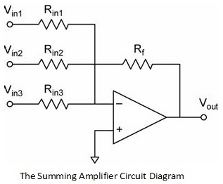Multiple inputs are applied to the inverting input terminal of the Op Amp, while the non-inverting input terminal is connected to ground. Due to this configuration, the output of Voltage Adder circuit is out of phase by 180o with respect to the input.

VOUT = VOUT1 + VOUT2 + . . . + VOUTn

VOUT = – [(Rf / R1) V1 + (Rf / R2) V2 + . . . + (Rf / Rn) Vn]

NonInverting summing Amplifier

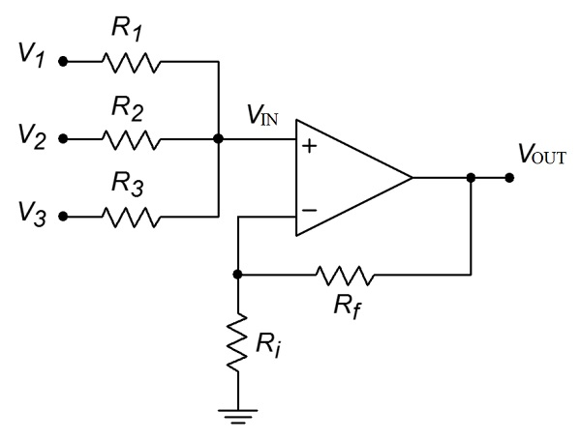The input voltages are applied to the non-inverting input terminal of the Op Amp and a part of the output is fed back to the inverting input terminal, through voltage-divider-bias feedback.

VOUT = (1 + (Rf / Ri)) ( (V1 + V2 + V3) / 3)

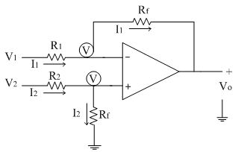Differential amplifiers amplify the difference between two voltages making this type of operational amplifier circuit a **Subtractor** unlike a summing amplifier which adds or sums together the input voltages. This type of operational amplifier circuit is commonly known as a **Difference Amplifier**configuration.

Vo = Rf/R1[V2 - V1]

**VERIFICATION:**

Inverting summing amplifier

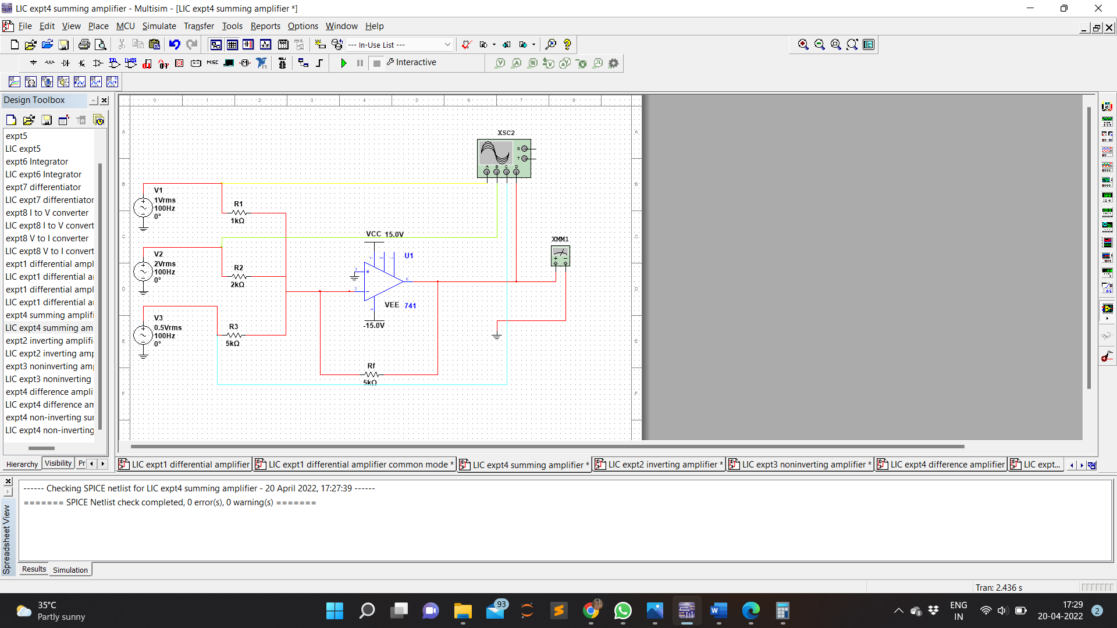Circuit Diagram

Waveform

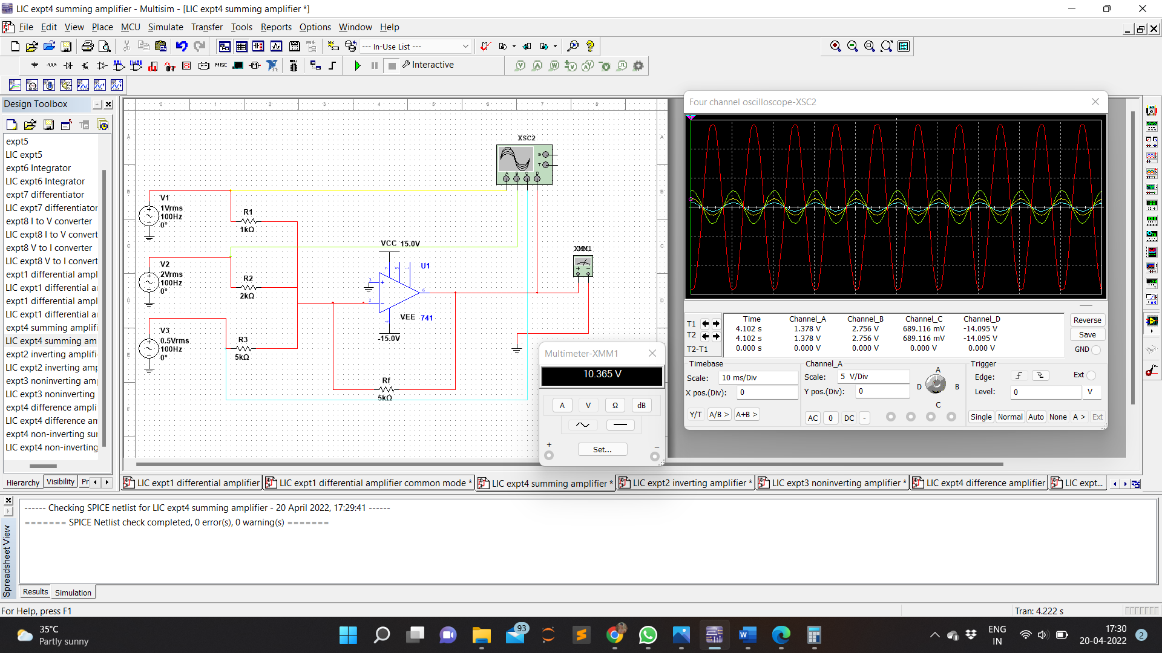

NonInverting summing amplifier

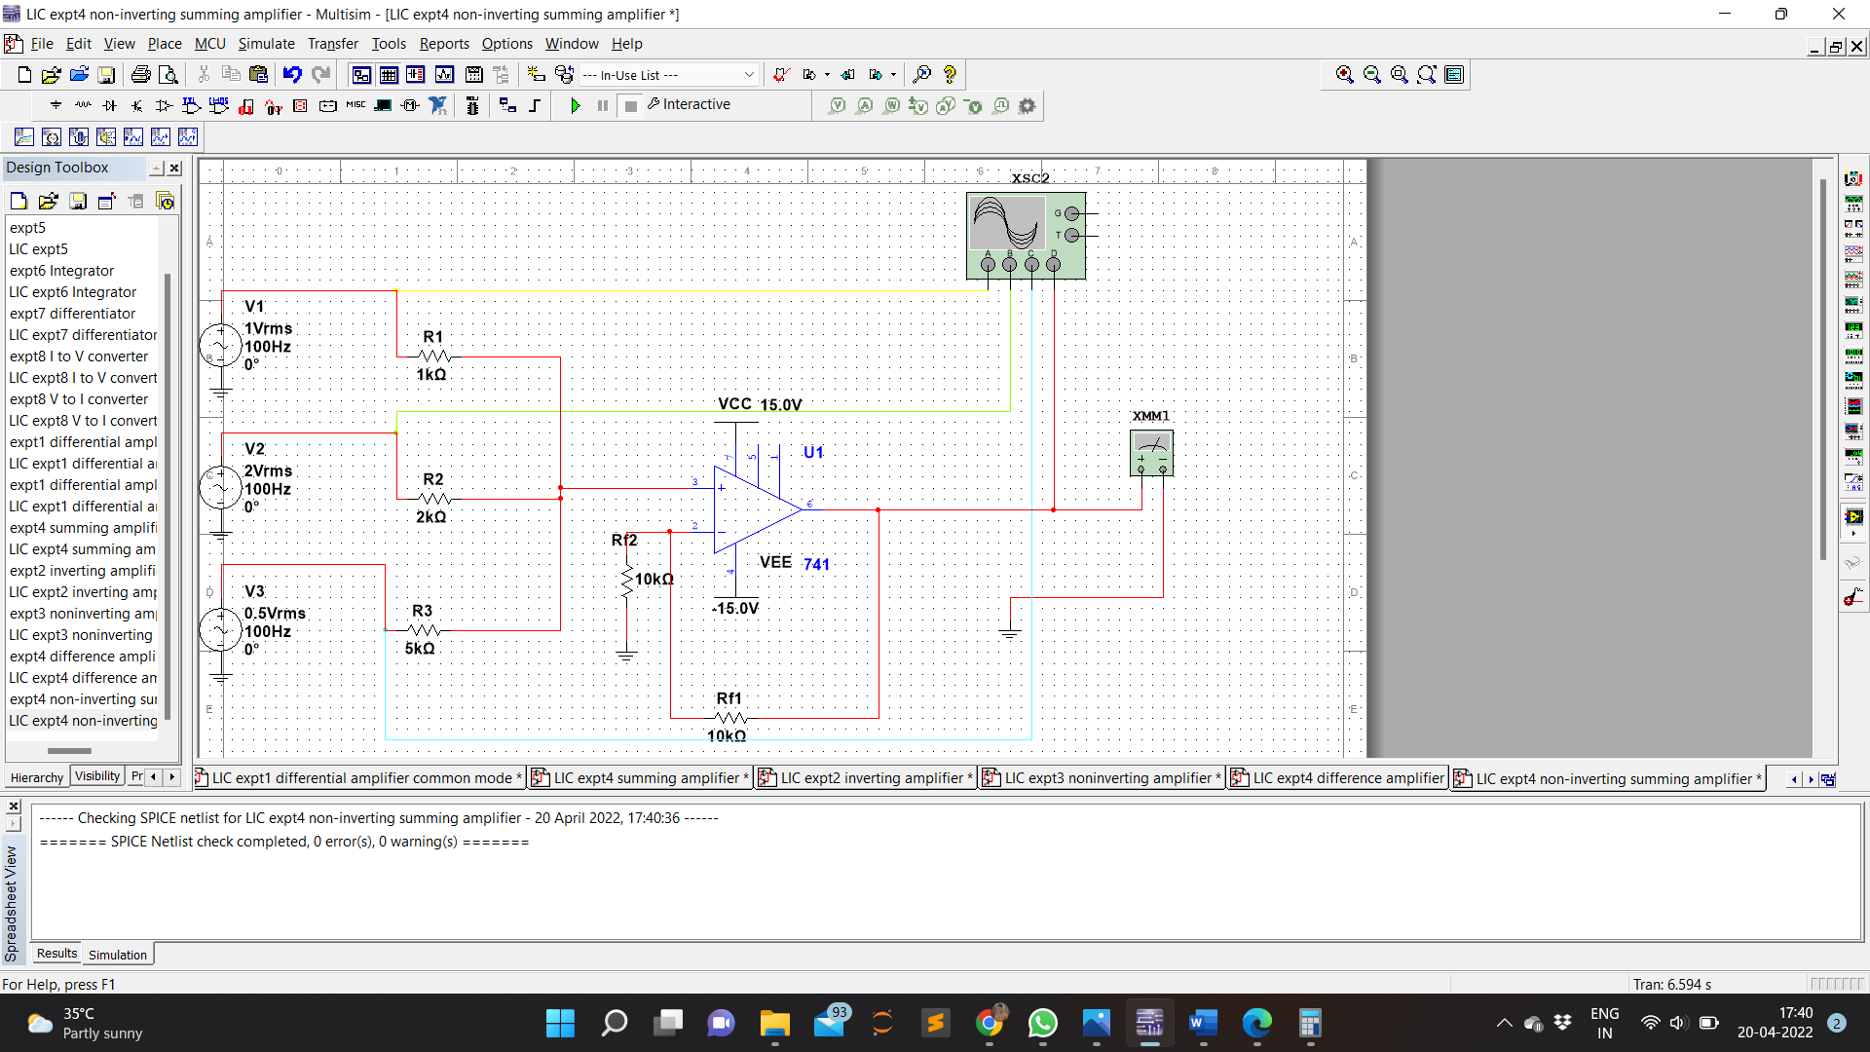Circuit Diagram

Waveform

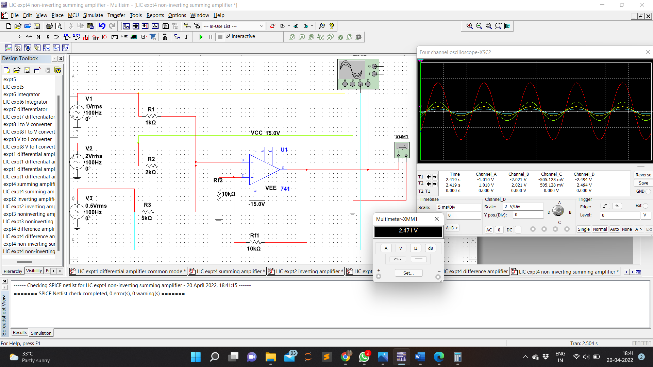

Difference amplifier

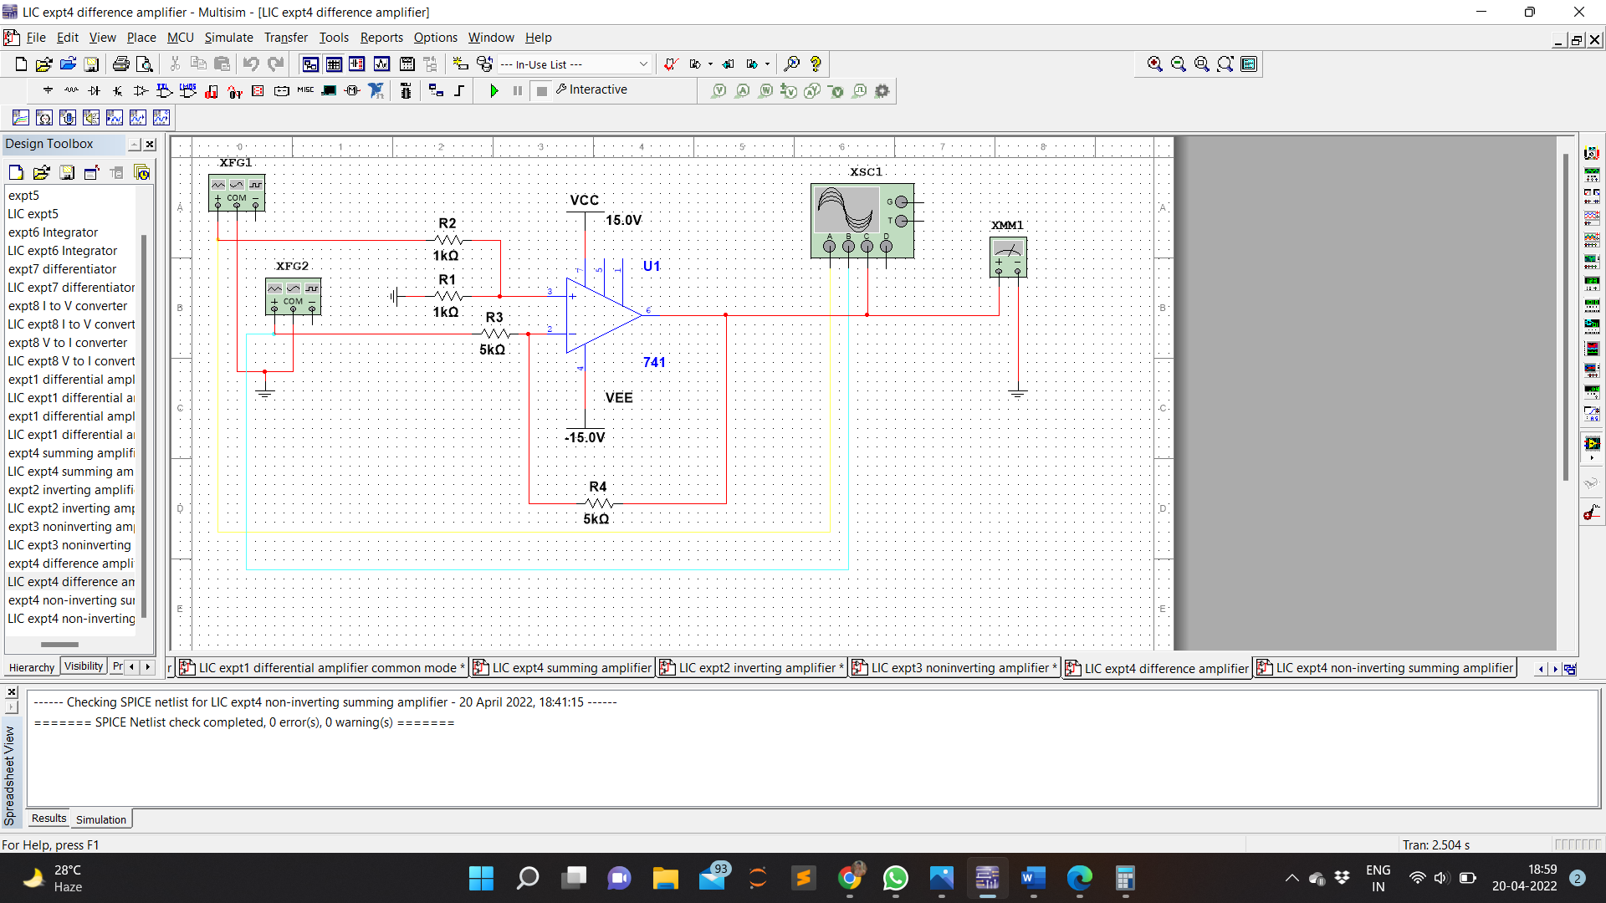Circuit Diagram

Waveform

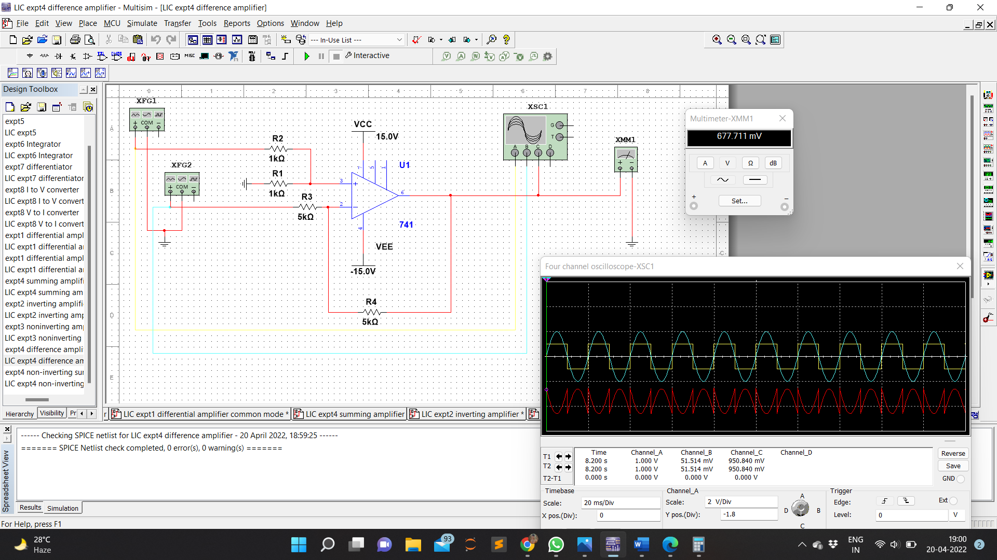

**CALCULATION:**

Summing amplifier

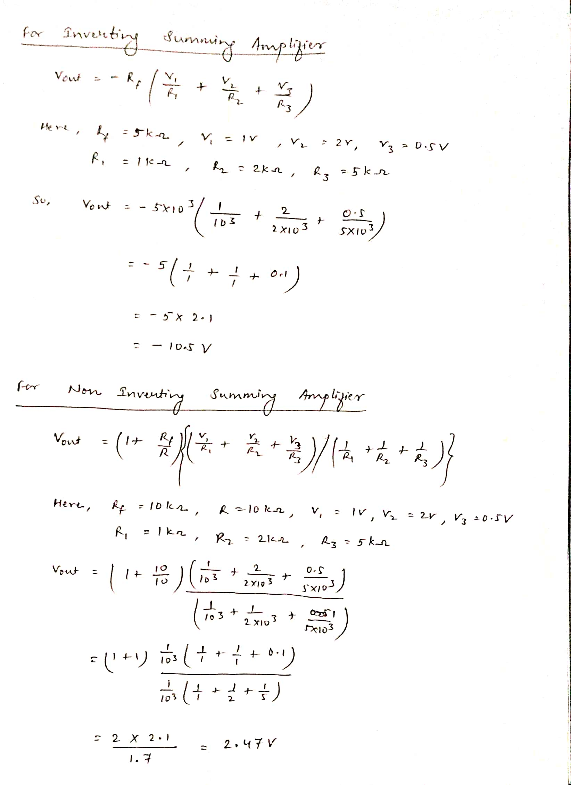

Difference amplifier

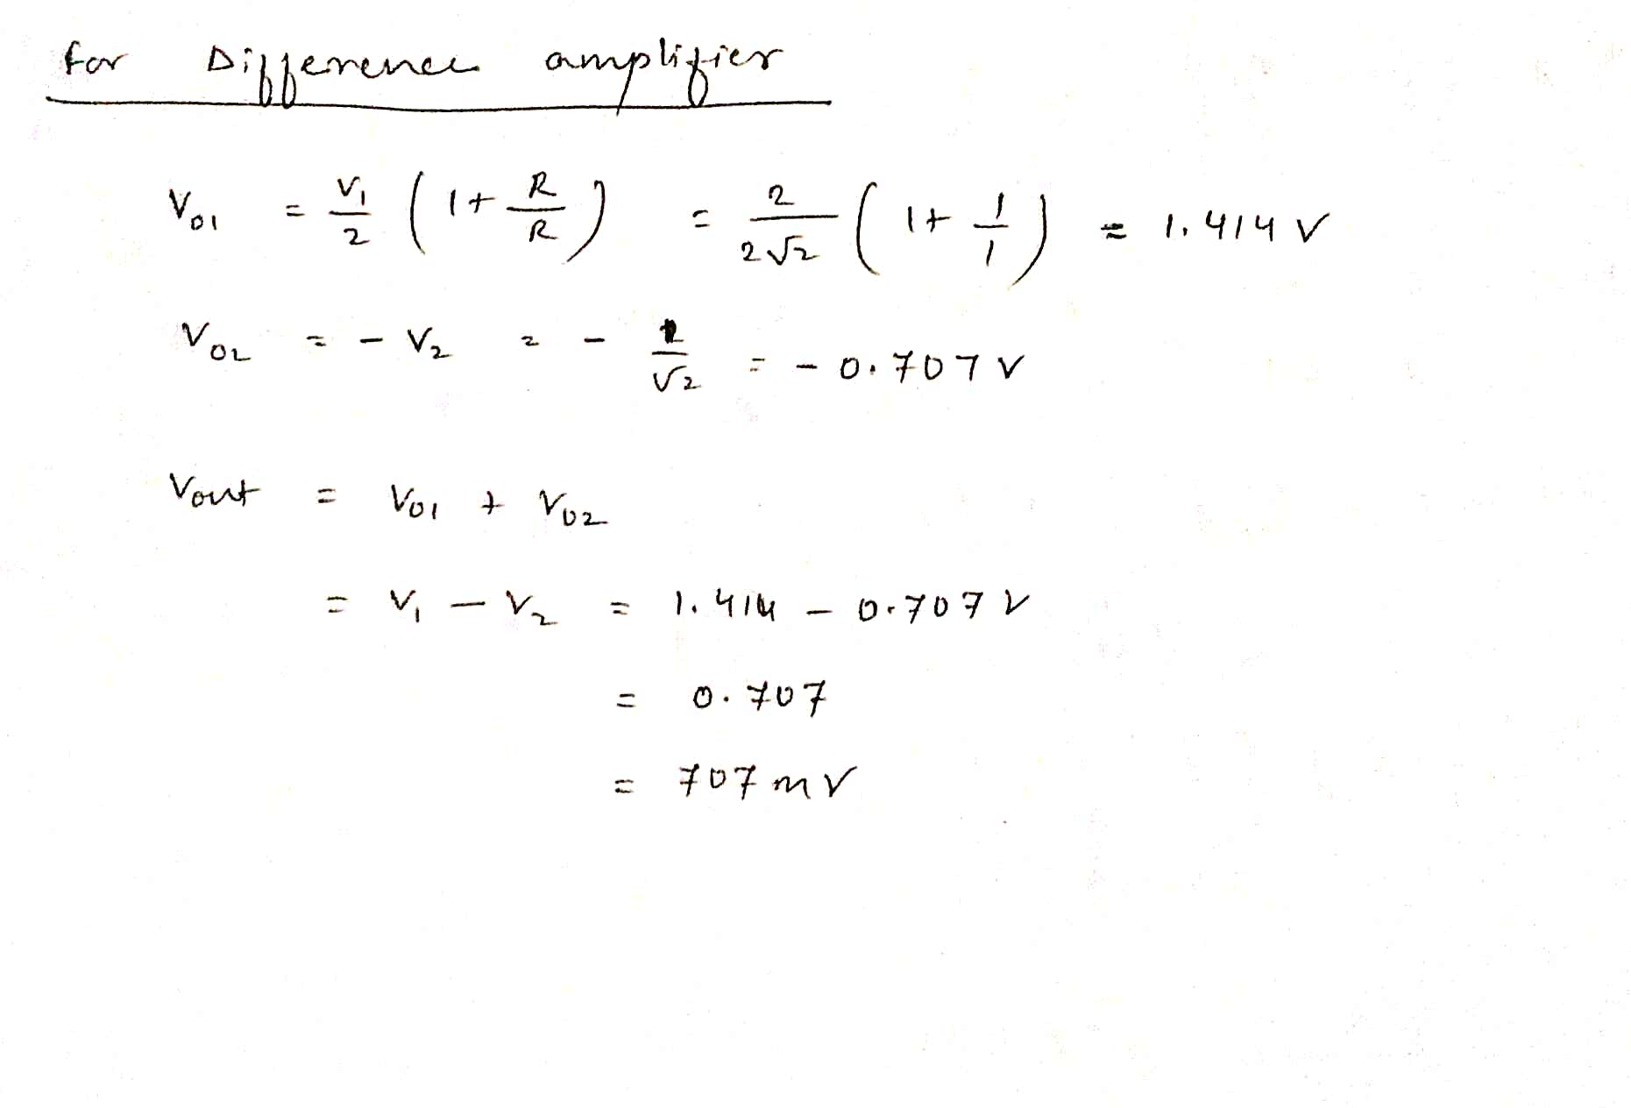

**RESULT:**

Summing and Difference amplifier is designed , simulated and verified using multisim.